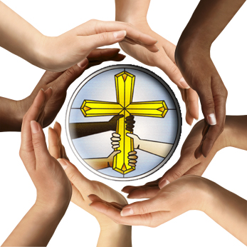
Fellowship

God of perfect fellowship:
Three in One,
One in Three.
Triune community,
flawless union,
eternal harmony,
I bless you for the reflection of community given to your people:
brothers and sisters in God’s household,
the assembly of the firstborn,
the church of the Living God.

Behold, how good and pleasant
when brothers dwell in unity,
bearing with one another in love,
maintaining Spirit unity with eagerness.

How precious to experience the bond of peace.
How wonderful to glimpse divine kindness,
tenderheartedness, patience, humility, and gentleness.
And to forgive as Christ forgave −
this is truly a supernatural power to see in rebels such as we.

Continue Your transformation.
Redeem us from the blame of Adam,
the jealousy of Cain,
the vengeance of Lamech,
the violence of the serpent’s seed,
and the gossip of Ham.

And go deeper.
Make us accept as kindness the strike of rebuke,
to find the seeds of truth in undeserved criticism,
and let no bitter root dwell in us to disturb the sweetness of fellowship.

Christ, Your bride awaits You.
Prepare us for this experience of perfect unity.
Father, demonstrate your wisdom to heavenly authorities.
Break prejudices of race, class, wealth, and ability.
Spirit, maintain the unity formed in one Body.
Reveal to the world divine fraternity, kinship, friendship.

